Collateral Map

5 Village, Svay Rolum Commune, Sa Ang District, Kandal Province

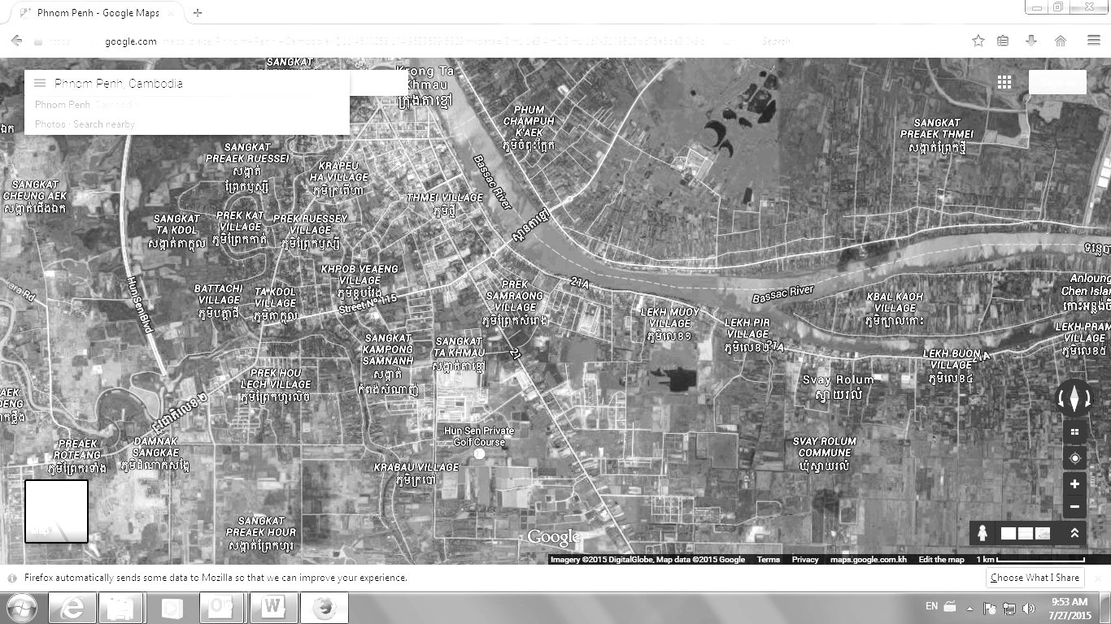

Subject Property

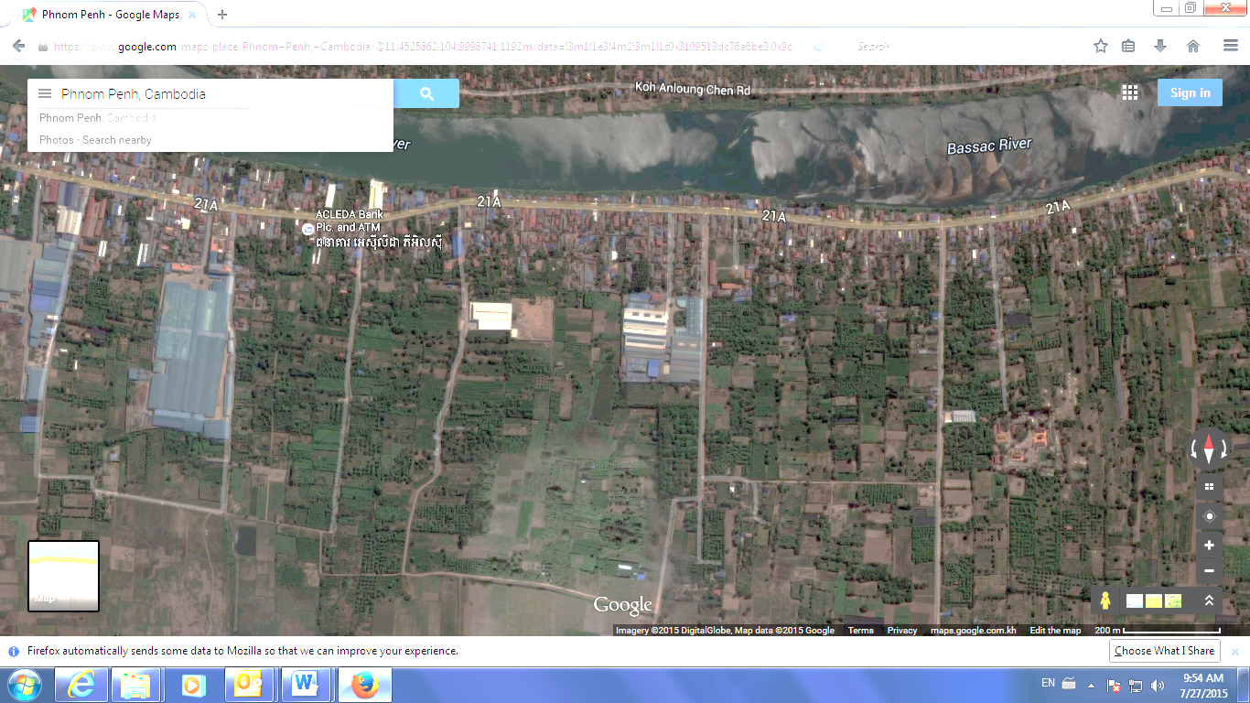

Subject Property

Collateral View

5 Village, Svay Rolum Commune, Sa Ang District, Kandal Province

